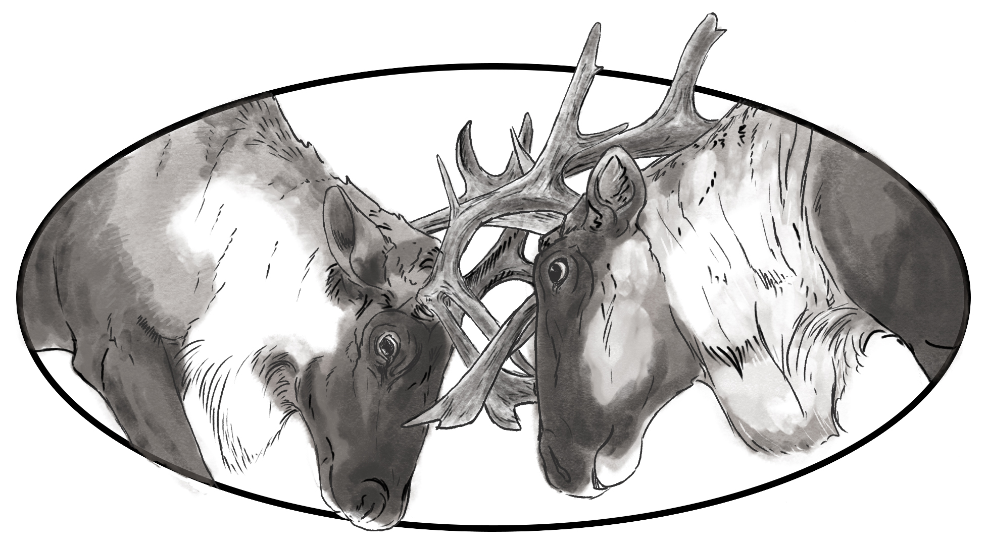
 |  | Location: MS Teams Meeting
 |  | Date: Monday, October 18, 2021
 |  | Time: 1315-1615 Pacific

Revelstoke Complex and Central Selkirks

Technical Working Group

Members (grey indicates not in attendance)
Genevieve Lachance (moderator) | Christine Friedrichsmeier (notes) | Guests: Rob Serrouya, Erin McLeod
Tim Eugene | Deb McKillop | Aaron Deans
Rieva McCuaig | Rob Steenweg | Robyn Laubman
Aaron Reid | Celia Nord | Leo DeGroot
Gwen Bridge | Brier Cadden | Laura Machial
Corey Bird | Allison Pagett | Darcy Peel
Tina Donald | Colleen Marchand | Mark Thomas
Andrew Malucelli | Bevam Ersnt | John Krebs

NOTES

1:15-1:30 Welcome (Genevieve Lachance)
Genevieve welcomed everyone and went through the action items from the last call.

1:30-2:00 Restoration (Rob Serrouya, Alberta Biodiversity Monitoring Institute, Aaron Reid)
Agenda: Rob Serrouya and Aaron (TBD) will give an update on the restoration group in the Revelstoke area, Aaron on priorities for the Central Selkirks and the Provincial strategy that was developed earlier this year.
Rob Serrouya gave an update on the restoration group on the Revelstoke area (see presentation).
- Q: How did you determine forest use?
  - A: Descriptive, didn’t factor into the weightings. Applicable to boreal, not really mountain caribou.
  - Mainly for impeding wolf movement on roads, it doesn’t include cutblock rehabilitation or such.
- Q: How will it fit into Prov process?
  - A: Provided to HCTF and proponents to act as a decision-making tool for where to initiate work. Now there are 2 tools but waiting on linework approvals.
  - Wildlife Infometrics (Scott McNay) – 220 page Tactical Restoration Plan on deep-snow caribou herds will be released once caribou linework can be released – will help with restoration project applications as well as priority tools
- Want to impede wolf movement but need to reduce wolves as well.
  - Wolf territories would be a good unit of measure of accomplishment – about 2-3 landscape units (LU).
  - Difficult to tease out the effects of wolf removal vs restoration of linear features (impeding wolf movements)
- Human disturbance and access to core habitat is a bigger factor in the south (BC)
ACTION: Genevieve to add restoration to agenda to follow up for next meeting.

2:00-2:15 Nakusp Maternal Pen (Erin McLeod, Arrow Lake Caribou Society)
Erin presented an update on the Nakusp Maternal Pen, first showing its location on maps.
- Confirmed funding from CRP to finish pen in April 2022.
- Ordered supplies for electric fence – priority before snowfall
- Game cameras
- Blind (for caribou observation)
- Nice interior habitat – higher elevation (cooler), old growth, will have misting station and will push snow under canopy from outside the fence
- Application in progress for funding for work once the caribou are in the pen
- Have collected all the needed lichen, pellets are coming
- Plans, ethics, etc., are all done
- Group discussed concern over animals in the pen if we get another “heat dome” – under the guidance of Provincial Veterinarian – could let them out
- Opportunity to do things better and smarter than the Revelstoke pen – need to avoid high temperatures. Yes, but can’t wait on ideal conditions – highest elevation has 2m of snow most of the year – not operable.
- Deb has data she can provide Erin.
  - Plan to capture 8 cows SW of Trout Lake this winter
- Also, some funding from the US – will be paying for the capture
- Lots of planning still to do
ACTION: Deb will connect with Erin after the call regarding the data.
ACTION: Indigenous communities interested in the maternity project to contact Erin Macleod at al.caribou.society@gmail.com
ACTION: Erin to send data, maps to Genevieve to place in the group’s online folder.
- CRP has funding to hire Cory Legebokow – waiting on approvals. Experience with Revelstoke pen.

2:15-2:30 South Columbia and Frisby-Boulder-Queest Herds (Aaron Reid, Corey Bird)
- Q: Translocation of caribou – most herds will need transplanted caribou to survive, but no decision-making process for this.
  - Assumption that animals used for conservation breeding could be used in a viable herd where they could help survivability
  - Still discussion at this point

2:30-3:300 Old Growth Initiative (Deb MacKillop, Regional Ecologist)
Deb spoke to the group about the Old-Growth Initiative in Revelstoke – see presentation
ACTION: Deb to provide Genevieve with presentation
- In Revelstoke, caribou and old growth are highly linked for policy, more than anywhere else in BC
- Old growth is defined as older than 250 years for all BEC zones
- Caribou GAR order contributes to old growth protection
- But still deficits in OGMAs, old forest
  - not enough old forest in OGMAs to meet targets in certain areas – is this because of discrepancies in vegetation cover inventory? Or not enough old growth in OGMAs
- Old growth in high-elevation non-harvestable, then in THLB, then need to recruit if you don’t have enough
- Numbers not what industry using, so draft, as well as other means licensees are using to meet their requirements in their plans – need to work with licensees
- Inland temperate rainforest old growth is a hot topic in the news, also relevant to caribou
- Once deferrals are announced, we can look at caribou and old growth overlaps vs AAC
  - Once this package is released it should be brought to this group.
  - It will be brought to indigenous nations for review
  - Deferral is for 2 years – it’s not protection – it simply allows for more review and discussion
- Old Growth Strategic Review
  - Report April 2020, released in September
  - Campaign promise to implement all 14 recommendations
  - Press release came out in early August of this year
  - We aren’t doing a great job on biodiversity in old growth
  - Paradigm shift to ecosystem health
  - OGMA issues defined in report
Questions and answers: Gwen spoke about maps
ACTION: Genevieve to add Gwen to next agenda to speak about the recovery and mapping work that she’s been working on with Rob Serrouya
- What percentage of old growth is caribou habitat? What about mature forest?
  - Looking at the most ancient forest – giant cedars are at the top of the priority
  - Old forest important ecologically, takes a long time to replace – climate change is a factor
  - Caribou – old growth provides habitat for caribou, “anti-habitat” for moose
  - Large overlap, but not 100%. You may have good old growth that has no caribou.
  - Economic values will be impacted in Revelstoke (AAC)
  - Caribou need vast areas, lots of which is not in old growth
  - Conservation vs AAC

3:00-3:15 Break – actual 3:22-3:27

3:10-3:25 Funding – ECCC (Robin Steenweg)
- Application-based and also internal directed funding
- Internal directed funding:
  - Community-led
  - Agathe helps Robin coordinate
  - Could be done with ECCC or without
  - December 7th – ECCC would help co-develop
  - Caribou – including capacity, on-the-ground projects
  - Robin will provide an example in the near future
  - Matching 20% fund required over the life of the project (1-3 years)
  - April (new fiscal)
  - Structured for a single recipient is much easier and faster to process
- Expressions of interest (presented at SAR workshops last winter) – application-based
- Just email Robin or Agathe about your project and work with you on your proposal
ACTION: Robin to send more information about the second process, and proposal example or other info to Genevieve

3:25-3:50 Roundtable
- Brier – interested in both caribou and old growth
- Cory Bird – looking forward to heli-ski talk by Darcy next time
- Erin McLeod – N/A
- Bevan – N/A
- Gwen – OKIB has put forward a caribou habitat and recovery protection plan – no response in a year though from the provincial government
  - Nations spoke to the need for decision-makers at the discussion tables
  - informative meeting; wants to see provincial responsiveness; what are the economic analysis of all the FN proposals? Habitat and economics.
- Aaron Reid – should add recreation to the agenda – snowmobiles especially.
ACTION: Genevieve to add Aaron to the agenda (next meeting or two) to talk about recreation
- Robyn L – ToR important for this group, formal understanding re: what we can accomplish in this group; predator reduction & recreation will also keep us busy
- Robin Steenweg – N/A
- Tim Eugene – wants to be more aware of corporate structure, as a leader. No connection right now. Wants to know who to talk to.
  - TWG, so no ADM, but often Darcy attends. Leo is directly linked to leadership of CRP, so you would talk to him. Sometimes others like John Krebs
- Tina – important to work together, build relationships – between FN. Stewardship and education are so important – coho, grizzly, caribou.

3:50-4:00 Communication Strategy and Budget, and Other Program Updates (Leo DeGroot)
- Communication Strategy and Budget
  - Leo was surprised by comments of low awareness on predator reduction engagement, yet have been really thorough
  - GCPE (govt communications)
  - Funding for 2 more communications people within SAR branch (one contractor, one internal staff)
- No other program updates
- Still looking to replace Bryan Williams
- Also looking to bring more engagement staff in NE

4:00-4:05 ToR, Contribution Agreement Update (Genevieve Lachance)
- Genevieve sent out ToR to go through line by line with FN via email

4:10-4:15 Next Steps (Genevieve Lachance)
- Next meeting November 22nd
- For agenda: tactical restoration planning results (Joelle)
- For agenda: review workplan

-- Meeting ended at 4:00 --

ACTION SUMMARY
- Genevieve to add restoration to agenda to follow up for next meeting.
- Deb will connect with Erin after the call regarding the data.
- Erin to send data, maps to Genevieve to place in the group’s online folder.
- Deb to provide Genevieve with presentation
- Genevieve to add Gwen to next agenda to speak about the recovery and mapping work that she’s been working on with Rob Serrouya
- Robin Steenweg to send more information about the application process, and proposal example or other info to Genevieve
- Genevieve to add Aaron to the agenda (next meeting or two) to talk about recreation

